 | The Atmosphere
1 | A layer of air surrounds the earth. This layer of air is called the atmosphere. The atmosphere is composed of a mixture of solids, liquids, and gases. The common gases found in the air are oxygen and nitrogen. The air is 78% nitrogen and 21% oxygen. The other one percent of the gases includes argon, carbon dioxide, water vapor, neon, helium, methane, krypton, xenon, hydrogen, and ozone.
2 | Nitrogen and carbon dioxide are used by plants to produce oxygen. Then, animals use the oxygen. Ozone forms a layer in the atmosphere that helps protect us from ultraviolet radiation from the sun. None of these gases are weightless. Their combined weight pressing down on the earth is called atmospheric pressure or air pressure. Atmospheric pressure is measured with a barometer.
3 | The atmosphere is divided into layers. The layer nearest the earth is the troposphere. This layer is the air we breathe and the layer where most weather forms. It is approximately five miles thick at the poles and ten miles thick at the equator. The second layer is the stratosphere. Because of the layer of ozone, which is in the middle of this layer, the top of this layer is warmer than the bottom. The third layer is the mesosphere. The temperature drops dramatically as the height increases in this layer.
4 | The fourth layer is the thermosphere. Here the temperature rises, and the air molecules are spaced very far apart. The top layer is the exosphere. It starts at 435 miles above the earth. The ionosphere is a layer that overlaps the upper mesosphere and the lower thermosphere. The air in this layer is composed of ions or electrically charged particles which are formed by the sun’s radiation. Layers of the ionosphere reflect radio waves and are important to long-distance communication.
5 | 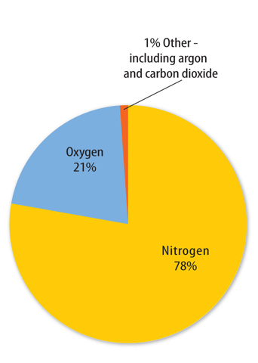

Define the following terms | Definition
- Atmosphere
- Atmospheric Pressure
- Troposphere
- Stratosphere
- Mesosphere
- Thermosphere
- Exosphere
- Ionosphere
- Ions
Answer the following questions. | Answers
- What two main gases make up the atmosphere? What percentages of the atmosphere do each make up?
- What gases make-up the other 1% of the atmosphere?
- Explain which gases are used by plants. Explain which gases are used by animals.
- In which layer would we find ozone? What is the effect of ozone on this layer?
- What is the main idea of the text? What are 3 pieces of evidence that support the main idea?
- Use the words below to label the layers of the atmosphere.  Exosphere  Mesosphere  Thermosphere  Troposphere  Stratosphere | 